Unit 4 - Lesson 3 - Establish Information Delivery Milestones
Lesson 3 of 6

Lesson Objectives
In this lesson we aim to:
Understand the Establishment of Information Delivery Milestones

Project Information Delivery Milestones
The appointing party will establish the project’s information delivery milestones in accordance with the project’s plan of work and consider the progressive information exchange deliverables.
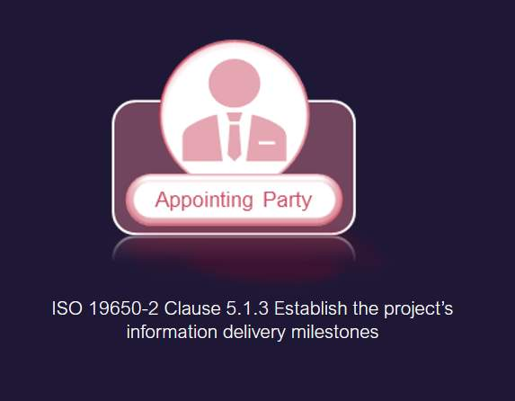
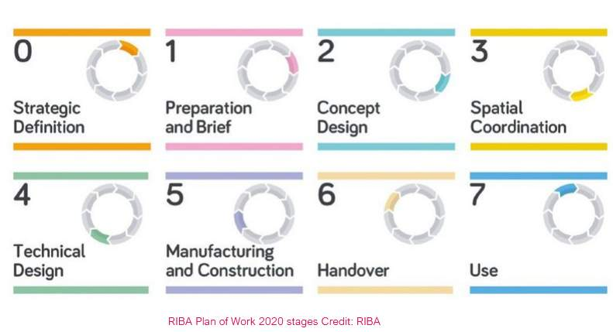
Audio transcript (00:49)
Information to be delivered to each milestone in accordance with the project information requirements, PIR. The appointing party will establish the project's information delivery milestones in accordance with the project's plan of work and consider the progressive information exchange deliverables. Number one, multiple information delivery milestones can be established within a single work stage. Example project information delivery milestones include regulatory approval and public consultation. Number two, an example of the project's plan of works is REBA work stages as shown. REBA plan of work provides a framework for architects to use on projects with their clients and project milestones are typically based upon this. The appointing party needs to define the number of key decision points and when they occur in relation to work stages.
Source audio: Lesson 3 - Establish Information Delivery Milestones - ISO 19650 (1).mp3

Typically before an Appointing Party has decided on the brief, it is likely that they will have to:Justify the project.Appoint advisers.Assess the feasibility of the project.Carry out options studies and select the preferred option.These stages involve sequential high-level decisions. However, typically they are not listed as project stages in standard industry project plans, which tend not to recognise the importance of early employer processes.
The Appointing Party should define their decisions in the way that suits their needs, rather than adhering to industry standards that may have been developed for a particular discipline or procurement route.

BIM Information Delivery Workstages
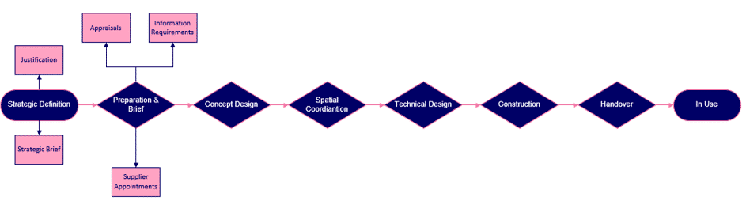
The first two stages have been broken down into sub-sections where important employer decisions have been identified that are not included within the RIBA plan of work.
The end of each stage is marked by an employer’s decision point, or gateway, at which the employer needs specific information to help them decide whether the project has developed satisfactorily and whether it should continue to the next stage.
Strategic Definition
'Business justification' is the first part of the 'Strategic definition' stage. It involves making crucial decisions about whether to proceed with the proposed project. the employer identifies a need that could require the development of a newly built asset.
They then prepare a statement of need that describes the requirements for the potential project. This will later develop into a strategic brief.
The employer then prepares a preliminary business case based upon the statement of need. This offers a justification for the investment required by the potential project.
PIR question for this stage - Does the preliminary business case give sufficient justification for the project?
During Strategic Brief – a team is appointed. The employer's internal team develop the information in the statement of need and preliminary business case into a strategic brief that describes in more detail the requirements the built asset will have to satisfy. The strategic brief should be as detailed as possible and should provide sufficient information to enable the appointment of advisers. Key stakeholders should be involved in preparing the strategic brief, including, where possible, the operators of the building.
PIR Question for this stage - Has the strategic brief been developed sufficiently to appoint advisers to carry out feasibility studies and option appraisals?
Appraisals is the first part of the 'preparation and brief' stage. It involves assessing whether the project is feasible, and whether there is a preferred option that should be developed. The advisers or consultants undertake feasibility studies to establish whether the project is viable.
PIR Question for this stage - Is the project feasible?
Do option studies provide sufficient information to be able to select a preferred option?
Information Requirements is the second part of brief stage - It involves preparing info requirement documentation for the appointment of suppliers (Lead & Appointed Parties) PROJECT Brief, EIR, BIM protocol etc
PIR Question for this stage - Are the employer's information requirements developed sufficiently to make appointments?
Supplier Appointments take place based upon information requirements and the scope of the brief. Capability and capacity as well as an understanding of the info requirements should be demonstrated.
PIR Question for this stage - Do the proposals sufficiently answer the information requirements? Is the capability of the suppliers suitable or is training required?

BIM Information Delivery Milestones
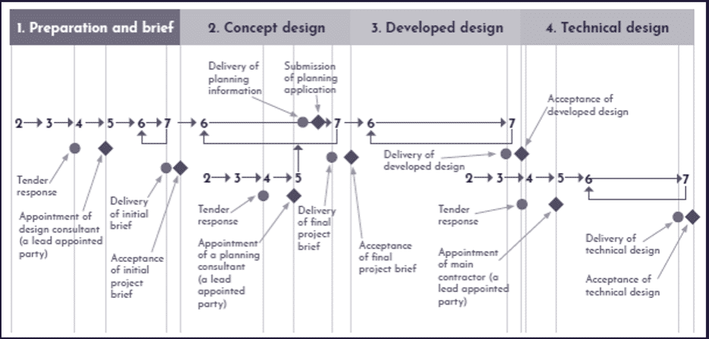
UK BIM Framework Guidance Part D: Figure 8: Example of key decision points and information delivery milestones in relation to the RIBA work stages 2013
Audio transcript (00:33)
This diagram shows the information delivery process associated with a number of key decision points. This is in the context of a design and build procurement through to the end of the REBA Work Stage 4 and in respect to three of the lead appointed parties involved in this project. The circles represent an information exchange and the diamonds represent a key decision point. See that there is always a period of X weeks between the two in order to check and review the exchange. Decision timeframes are also typically documented within the project specific EIR.
Source audio: Lesson 3 - Establish Information Delivery Milestones - ISO 19650.mp3

Lesson Summary
Lesson complete! You are now able to:
Understand the Establishment of Information Delivery Milestones.
[CONTINUE]

